

**Master of Science Thesis**

**Mid-term Review**

**Multi Energy Systems:**

Assessing energy flexibility in industrial parks using multi energy modelling

**Thesis Project Name:** Investigating Unknown Flexibilities Provided by Power-to-X Converters Considering Grid Support Strategies

**Thesis Supervisor:** Asst. Prof. Milos Cvetkovic

**PhD:** Digvijay Gusain

**MSc. Student:** Bekir Caner Yagci (4857089)

**Version Control:** <https://github.com/caneryagci/Multi-Energy-Systems-Thesis-Project.git>

Table of Contents

1. Problem Statement 3

2. Research Questions 3

2.1 Model Related Research Question 3

2.2 Industrial Area Specific Research Questions 3

3. Methodology 4

3.1 Hypothetical Maasvlakte 2 Energy Park (Microgrid with AC feeder) 4

3.2 Flexibility 5

3.2.1 Electrical System Flexibility (for Grid Operator) 5

3.2.2 Cost Flexibility (for Industry) 6

3.3 Hierarchical Control 6

3.4 Co-simulation & Energysim 7

3.5 Historical Data Processing & Probabilistic Weather 7

4. Modelling 8

4.1 Renewable Energy Sources (RES) 9

4.1.1 Wind Turbine Generator 9

4.1.2 PV Farm 9

4.2 External Grid and Optimal Power Flow 10

4.3 Industrial Loads 10

4.3.1 Power-to-Gas 10

4.3.2 Power-to-Heat 11

4.3.3 Electrical Base Load 11

5. Co-Simulation Scenarios 11

5.1 First case 11

5.2 Second case 11

6. Initial Results 11

7. Further Improvements 13

References 14

# Problem Statement

With increasing share of renewable energy, especially wind and solar, energy systems need more flexibility and new measures of flexibility for power balance throughout the operation and to reduce total cost and carbon emission. Multi energy systems, where different energy carriers interact at lower system levels, is proved to provide this flexibility by combining various energy domains with Power-to-X converters into one single system. Multi-energy systems with renewable energy sources (RES) are considered to have better technical, commercial, environmental and operational advantages than those conventional energy systems.

Growing shares of renewables lead to increasing demand for ancillary services, at the same time, less conventional plants become available to provide these services. Power-to-X converters, especially heat pumps and electrolyser have the potential to be a central part of an efficient, renewable and interconnected energy system, but there is still some research to be done. Many studies consider a heat pump or electrolyser as a black box which can be easily used for smart grid purposes. To evaluate the flexibility available from these resources and the impact they can have on the electrical grid, complex simulations need to be build that may not always be possible using traditional simulation tools [17]. Hence, demand for intelligent simulation techniques arises.

Most of the studies develop simplified models of multi-energy systems to estimate the need for storage in the future or to optimize cost with Mixed Integer Linear Programming (MILP) but many effects, especially dynamic effects, are neglected. These still have an influence on the system because storage, charging/discharging, networks and transient changes are highly dynamic [1].

Comparing with fuel cell systems, very few electrolysis models develop input-output models suited for control and flexibility analysis. Thus, knowing energetic optimisation needs, this topic remains an opened research domain; a lot of developments have to be accomplished in the modelling of phenomena, control design [18].

[20] suggests that, one of the best options for the integration of excess electric generation is to use it to cover heat demand in district heating grids by Power-to-Heat systems and to use heat pump for higher efficiency. Also, the event of adding new flexible load (P2H) to a system with already existing flexible load (P2G) and its effect on overall system flexibility still a gap in the literature.

# Research Questions

## **Model Related Research Question**

* What are the hidden flexibilities provided by Power-to-X modelling? *(Demand-side flexibility, Demand Side Management)*

## **Industrial Area Specific Research Questions**

* How much district heating demand can be supplied from curtailed renewable energy in Maasvlakte 2, Port of Rotterdam and what is its effect on system flexibility?
* How the existing flexibility affected when another flexible load is connected to the system? *(Supply-side flexibility, Curtailment)*

# Methodology

## **Hypothetical Maasvlakte 2 Energy Park (Microgrid with AC feeder)**

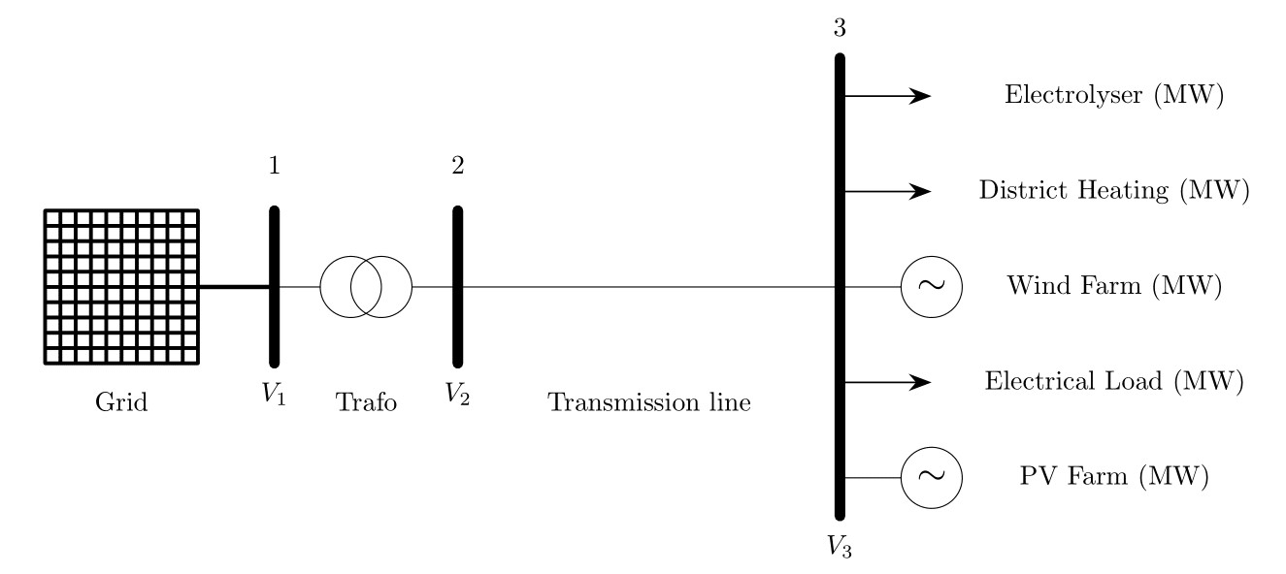

Fig.1 Considered Pandapower network

*“The outer contour of the Maasvlakte is an important location within the port area for achieving sustainable energy ambitions of the province of South Holland, the municipality of Rotterdam, the Port of Rotterdam Authority and the national government. The Covenant Agreement for the Realization of Wind Energy in the Port of Rotterdam (2009) states that by 2020 at least 150 MW of new wind capacity must be installed in the public port area. This brings the total capacity, new and existing turbines, in the port area to 300 MW [4]”*

Windfarm details in port area are given below:

* Coordinates: 51°57'10.2"N 4°00'22.9"E
* Wind Turbine Generator: GE, 3.6MW, DFIG
* Number of wind turbines: 10 (3MW) (Harde Zeewering) + 26(3MW) (Zachte Zeewering)
* Capacity: 108 MW

*“The floating solar park must be located on the Slufter, a depot for contaminated sediment of approximately 250 ha on the Maasvlakte. The westernmost location of the Slufter dredging spoil depot makes it one of the sunniest spots in the Netherlands. It is an ideal place for the generation of solar energy. It is estimated that it is possible to make approximately 100 ha of water surface available for the construction of a floating solar park, which could potentially deliver a capacity of approximately 100 MWp; accounts for the annual power consumption of approximately 33,000 households. This would make 'Zon op de Slufter' by far the largest floating solar park in the Netherlands [7].””*

PV Farm details are given below:

* Coordinates: 51°55'28.8"N 4°00'11.2"E
* PV Panel: 250 Wp
* Number of panels: 180.000<x<540.000
* Capacity: 45-135 MWp (apprx:100 MWp)

*“The high-temperature residual heat is transported from the port of Rotterdam via a pumping station powered by electricity. The heating is transported to heating centrals in Leiden, where it is dispersed to the already existing district heating network [5].”*

*“BP, Nouryon (formerly AkzoNobel Specialty Chemicals) and the Port of Rotterdam Authority are jointly investigating the possibilities of producing green hydrogen for the BP refinery in Rotterdam. Green hydrogen is produced by electrolysis of water using green power. Large-scale production of green hydrogen requires huge amounts of green electricity, for example from offshore wind farms, in addition to a very high electrolysing capacity [6].”*

Size of industrial loads will be decided in megawatt according to the measured generation capacity. Fig.1 illustrates the industrial multi energy system with AC feeder that is assumed as “Energy Park in Maasvlakte”.

## **Flexibility**

Flexibility has various definitions. The reason for that is, it can be necessary to address the different aspects of the energy system according to the primary concern or different measures based on the considered system [1]. Therefore, flexibility can be classified according to the primary concern of the researcher.

In this report, flexibility defined as ability of a system to response challenges caused by power fluctuations [15], and divided into two groups as electrical system flexibility where flexibility is measured from the balance between active power generation-demand, and cost flexibility where flexibility is measured from the total cost of the operation. These two flexibilities can be combined with various assumptions or measures. For example, cost flexibility can be added as third signal in the decision making of the system flexibility [15].

The key figures that characterize flexibility are activation duration (tact), holding duration (tflex,on), the amount of power (capacity) and deactivation period (trestore). [15] Parameter sweep will be implemented on holding duration in order to measure flexibility of P2X converters.

### **Electrical System Flexibility (for Grid Operator)**

System flexibility measures can be held from both sides of the network: generation and demand. Nearly almost any measure that can be taken from generation side has an equivalent demand-side counter measure. Those flexibility measures, taken from both sides of the multi-energy network, are explained below.

#### **Supply-side Flexibility**

Supply side flexibility consists of measures or technologies by which the output of power generation units can be modified to secure power balance in the grid. One of the ways to regulate power balance by generation is curtailment. Even though, it means losing electricity, it can be avoided if overall system flexibility is increased [1]. Therefore, the amount of curtailed Renewable Energy (RE) can be used to measure flexibility.

With excess RE, power production may need to be curtailed in order to stabilize the system if there is no storage available. Combining different energy networks with available storage, transmission losses and curtailed RE can be reduced and more flexibility can be offered.

One point here is the fact that capacity factor of Renewable Energy Sources (RES) is less than 1; therefore, the loss of electricity production is not proportional to power curtailed [1].

#### **Demand-side Flexibility**

Demand side flexibility consists of Demand side Management (DSM) ancillary services. Especially, load shifting is more advantageous compared to other DSM methods because it offers flexibility without compromising the continuity of the process or quality of the service. Load shifting will be provided by modifying the output flow rates of hydrogen and water for P2G and P2H respectively.

### **Cost Flexibility (for Industry)**

In this report, until now, flexibility is defined as electrical system metric through active power measurement. However, smart systems in industry can adapt and optimize their load control according to the electricity, gas and heat prices. For example, Energy storage can be used to store power during low demand and injecting it back into the system during low supply period. Therefore, flexibility can also be defined/measured differently as the reduction of the system total cost for a specific amount of time. This aspect of flexibility can be combined with grid ancillary services, depending on what type of cost/price signals considered, and it is especially important for industrial cases since commercial concerns are higher. Therefore, it will be considered in the following weeks of this project.

## **Hierarchical Control**

Primary concern for grid operators is the stability of the network. Therefore, at lower control level (OpenModelica), current controlled voltage source converter is modelled with real input connectors as illustrated in Fig.5, 6, 7. Grid support is implemented by controlling active and reactive power (P,Q) output of the models with PID controllers.

Primary concern in industrial operations is cost. Therefore, at higher control level (EnergySim/PandaPower), heat, gas, electricity prices, will be considered for decision making. The objective of the global control will be to minimize the operational cost.

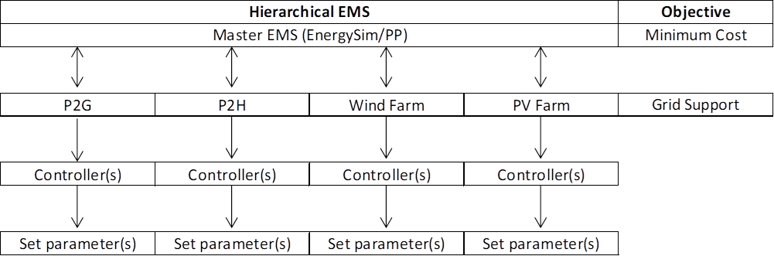

Fig.2 Hierarchical control

## **Co-simulation & Energysim**

Energysim [17] is used for co-simulation. Models, their inputs/outputs and simulation start time is illustrated in figure below. There are no results from this part yet. Therefore, exact step, exchange and total time is not known. However, considering the flexibilities that will be provided and the simulation time results from OpenModelica models, total duration have to be more than 5-7 hours (target: 24 hours) with 5-15 minutes exchange time.

* Simulation duration: 3600*7 (s)
* Exchange time: 120 (s)
* Step time windfarm: 3 (s)
* Step time PV: 3 (s)
* Step time P2G: 6 (s)
* Step time P2H: 6 (s)
* Step time pandapower:3 (s)

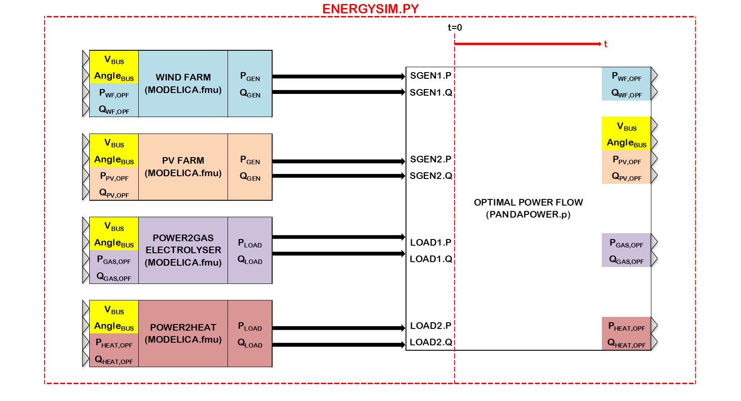

Fig.3 Co-simulation block diagram

## **Historical Data Processing & Probabilistic Weather**

Historical data process is summarized in the figure below. 2019 historical windspeed and solar irradiation data of Port of Rotterdam will be divided into 8 regions that is consist of 45 days. For every hour of each 45 day group a histogram will be created to calculate Weibull or Beta PDF parameters [19]. Later this parameters will be the input via CombiTimeTables.

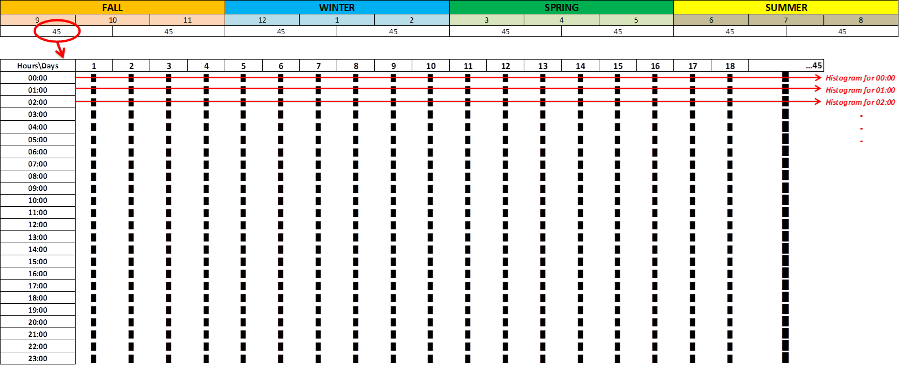

Fig.4 Histogram generation for PDF parameters

It is considered that Probabilistic Density Function (PDF) of Weibull and Beta for windspeed and solar irradiation generation respectively will be modelled based on historical data processing and the effect on renewable energy generations will be observed. (Probabilistic vs. Historical data) However, this type of simulation requires simulation duration for months and, during the modelling phase, it is observed that these models increases the simulation time significantly with the increased number of equations. Therefore, due to high computation time these models currently not in use. This part is not one of the main focuses of the project anymore, but same task can be implemented as pre-work in MATLAB and the resulting (minute or hourly) windspeed and solar irradiation data can be input as .txt to FMU’s.

* Weibull probabilistic distribution function is used for wind speed estimation. First, histogram tables will be created via historical data. Then parameters of the Weibull PDF (shape, scale) are calculated by curve fitting in MATLAB. Finally, Text files are created for hourly shape, scale parameters in “CombiTimeTable”.
* Beta probabilistic distribution function is used for solar irradiance estimation. First histogram tables will be created via historical data. Then parameters of the Beta PDF (shape, scale) are calculated by curve fitting in MATLAB. Finally, Text files are created for hourly shape, scale parameters in “CombiTimeTable”.

# Modelling

Various OpenModelica libraries, such as PowerGrids, PowerSystems, PVSystems, WindPowerPlants, AixLib, Buildings etc, have been considered in order to find the optimum balance between the simulation computation time and the resolution of the results. The controller models of PVSystems Library [16] has found useful for grid support analysis, but comes with increasing computation time threshold. As a result, iTesla Power Systems Library (iPSL) [14] has decided to be the best option for the desired amount of simulation time and level of detail.

Besides, P2X converters and RES modelled in object oriented Modelica Language, electrical network is modelled using PandaPower [8] as illustrated in Fig.1 and Optimal Power Flow (OPF) is carried out. Results of the OPF are the inputs of the Modelica models as can be seen in Fig.3.

## **Renewable Energy Sources (RES)**

### Wind Turbine Generator

3.6 MW DFIG_GE_Type3 wind turbine generator is modified from iPSL Library according to [12]. Behaviour of the model is that of a current controlled voltage source converter. Turbine model converts mechanical power coming from wind into AC power order considering power produced by generator. Electrical Control commands the active and reactive power generated based on the power system conditions and turbine model. Generator provides interface between the controller and network. It includes no mechanical state variables for the machine which included in the rotor model. Also, electrical state variables are reduced to their algebraic equivalents [12]. The net result is an algebraic, controlled current source that injects the active and reactive power specified by the WTG electrical control model into the network. Finally, the output of the generator is connected to Point of Common Coupling (PCC) via PV, PQ buses and transformer as illustrated in Fig.5.

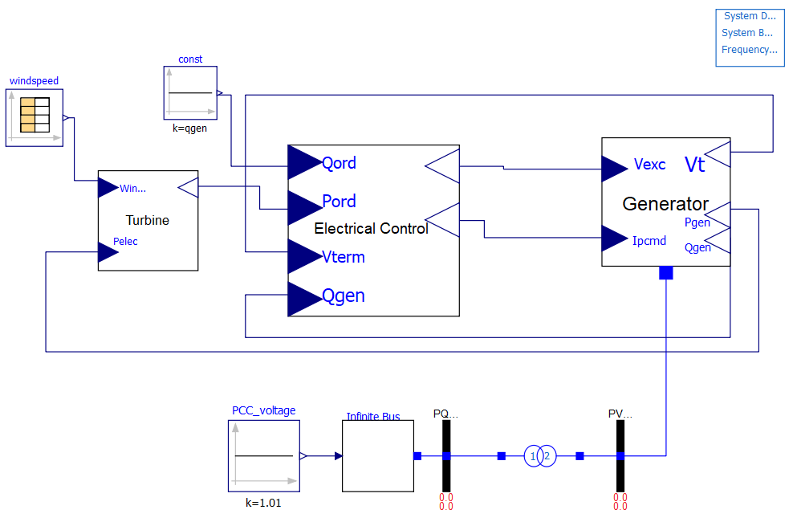

Fig.5 Wind Turbine Generator model

### PV Farm

PV Farm model from iPSL_Solar_KTH is modified according to [13]. PV block calculates cell/array current and voltage using solar irradiation, temperature and panel datasheet parameters. Also, controls DC bus voltage. DC busbar takes AC power as input to calculate new cell current and voltage. Controller calculates the active and reactive power that will be injected to the network considering system conditions. StaticGenerator provides the connection to the network. Finally, the output of the static generator is connected to Point of Common Coupling (PCC) via PV, PQ buses and transformer as illustrated in Fig.6.

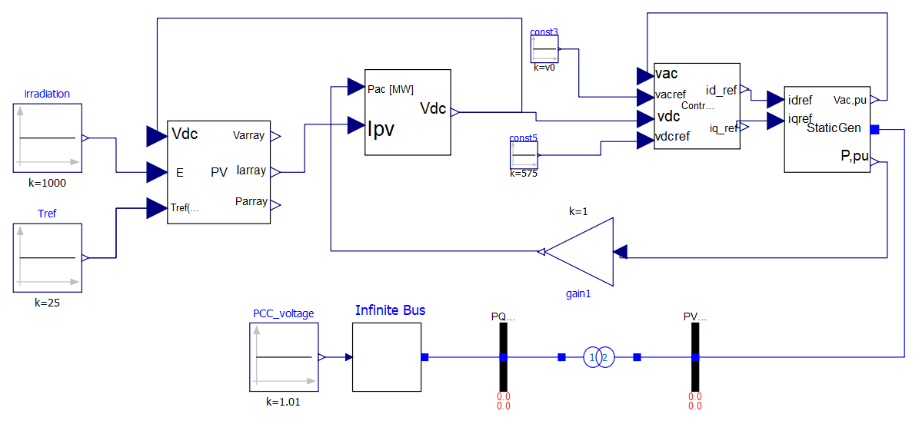

Fig.6 PV Farm model

## **External Grid and Optimal Power Flow**

External grid is modelled and optimal power flow is carried by Panda Power[8] as illustrated in Fig.1. Pandapower.py file and rest of the simulation models can be found in Github repository shared on the cover page.

## **Industrial Loads**

### Power-to-Gas

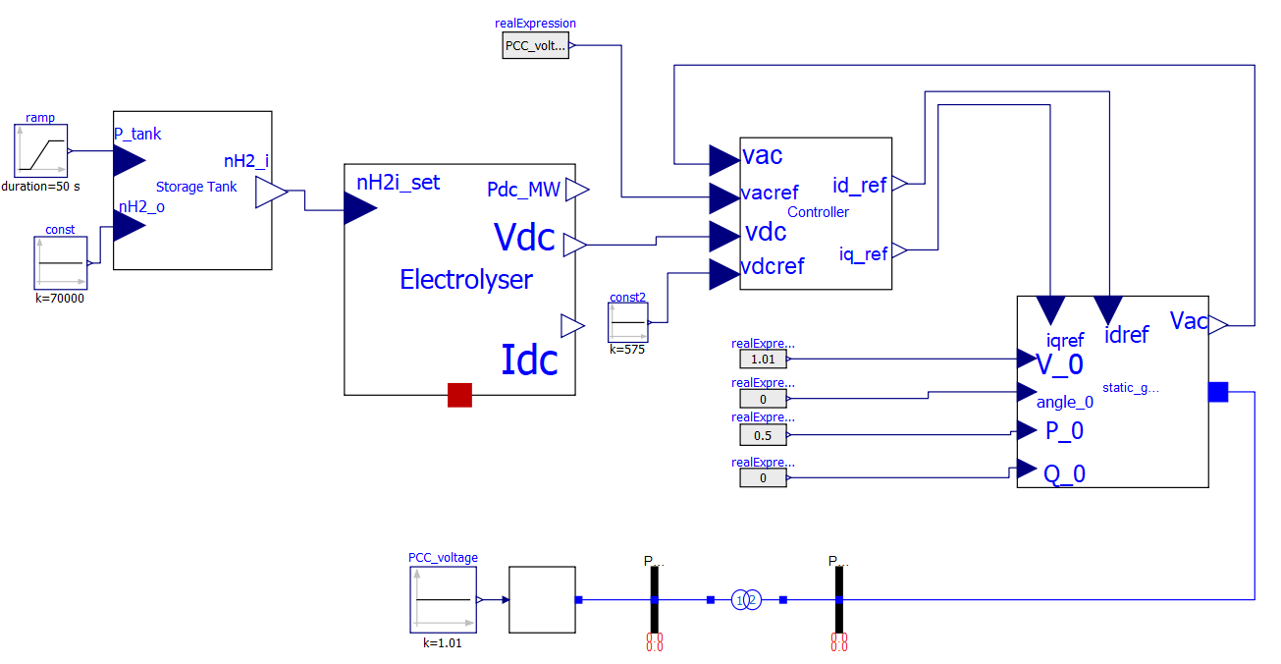

Fig.7 Power-to-Gas model

Storage tank, Compressed Gas Energy Storage (CGES) (700 bar), is modelled considering [11]. Pressure inside the tank is modelled as the integral of the difference between the input and output hydrogen molar flow rates, temperature and volume. However, it still needs improvements such as addition of losses and flexibility switch. Electrolyser is modelled considering [9, 10]. It takes hydrogen molar flow rate output of itself as input in order to calculate DC power consumed. Controller and Static Generator models are similar to PV Farm model. Finally, the output of the static generator is connected to Point of Common Coupling (PCC) via PV, PQ buses and transformer as illustrated in Fig.7.

#### **Flexibilty Switch:**

This part is explained in section 7.1.1.3.

### Power-to-Heat

Heat Pump supplying District heating demand with constant temperature thermal storage tank will be modelled similar to Power-to-Gas model. This part will be implemented after the first co-simulation case that is explained in the next section.

### Electrical Base Load

Connected in PandaPower, as illustrated in Fig.1, to represent the constant base load in the industrial area.

# Co-Simulation Scenarios

## First case

First, simulate Power-to-Gas system connected to renewables and plot system parameters in Energysim. Measure the flexibility of electrolyser/system and curtailed renewable energy.

## Second case

Connect Power-to-Heat to the previous system as load and do the same measurements again. Expecting reduced curtailed renewable power, better grid performance (less power injection to/from grid, more stable active power on feeder) and smaller storage size. Measure the flexibility.

# Inıtial Results

Fig.8 illustrates an overload initialization of wind turbine generator model for 300s with 600 intervals. Model compiles instantly or in 20-30 seconds due to the controller limiter values and power flow convergence. Therefore, controller needs to be modified according to correct parameters for 3.6MW DFIG WT of 108MW WF in order to have better simulation performance.

Active power starts at 1.3 p.u. and stabilizes at 1 p.u after 10s. Reactive power, oscillates between ±0.5 p.u and reaches limit values when step increase occurs at the terminal bus voltage. This result shows reactive power control needs tuning while active power control was successful.

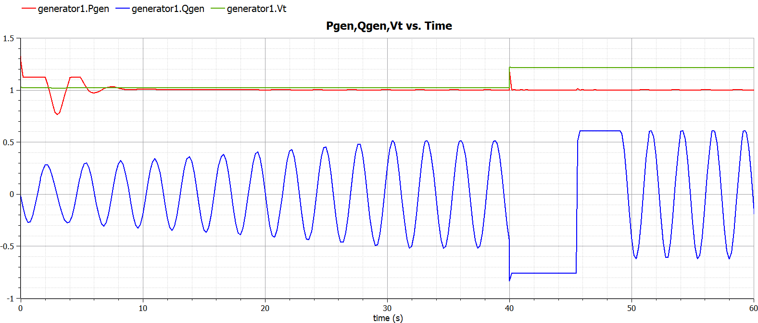

Fig.8 Wind Farm model response for 1.3MW PWF,OPF initialization and Vpcc step increase at 40s

Fig.9 shows the response of P2G system to ramp increase in tank pressure set value between 10-60s and step increase at PCC bus voltage at 90s. Active power response to new set value and active and reactive power response the PCC voltage step increase can be observed.

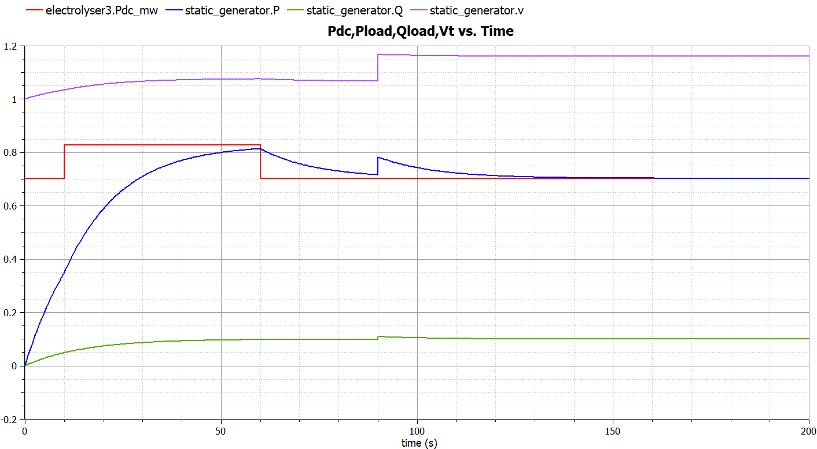

Fig.9 Power2Gas model response for Ptank,set ramp increase at 10-60s and Vpcc step increase at 90s

The controller of the PV Farm model currently gives error during compilation, it will be corrected soon.

# Further Improvements

#### **PV farm.fmu and Heating.fmu models**

These two Modelica models still need to be finalized in order to be used in co-simulation.

#### **Combine models in Energysim and implement higher control level**

Higher control level that considers cost during operation need to be implemented via PandaPower, EnergySim or a separate Controller.fmu in Modelica.

#### **Flexibility Control Block for “load following during tflex,on”**

An additional model block that turns (on/off) the flexibility operation for a specific amount of time, via 0/1 signal from Energysim, will be connected to “tank_pressure_set” for P2G and “tank_temperature_set” input for P2H. During flexible operation, pressure/temperature set value will change according to active power supply-demand mismatch and current pressure/temperature value of the storage. This will represent “Demand Side Management - Load Following” ancillary service [1].

#### **Create load profiles for normal operation and “load shifting”**

“Demand Side Management - Load Shifting” ancillary service, will be represented by shifting the output mass flow rates in text files [1].

#### **Add losses and ambient temperature connector “heatport”**

Transmission losses are particularly important for curtailment discussions. Equipment (Electrolyser, Heat Pump, Storage) thermal/static/dynamic losses are important for demand side flexibility discussions. Therefore, it is important to add such dynamics into the models and observe their effects on flexibility results.

#### **Resolution of weather data**

Currently, windspeed and solar irradiation historical data is hourly from Renewables Ninja [2]. However, Koninklijke Nederlandse Meteorologisch Instituut(KNMI) Dataset [3], offers resolution of every 10 minutes for the same location. Therefore, resolution of data will be increased.

**References**

[1] P. D. Lund, J. Lindgren, J. Mikkola, and J. Salpakari, “Review of energy system flexibility measures to enable high levels of variable renewable electricity,” Renew. Sustain. Energy Rev., vol. 45, pp. 785–807, 2015.

[2] Renewables.ninja. 2020. Renewables.Ninja. [online] Available at: <https://www.renewables.ninja/> [Accessed 12 May 2020].

[3] Data.knmi.nl. 2020. KNMI Datacentre. [online] Available at: <https://data.knmi.nl/datasets> [Accessed 12 May 2020].

[4] Port of Rotterdam. 2020. Renewable Energy. [online] Available at: <https://www.portofrotterdam.com/en/renewable-energy> [Accessed 12 May 2020].

[5] Celsius Initiative. 2020. Industrial Residual Heat And Transmission In Leiden, Netherlands - Celsius Initiative. [online] Available at: <https://celsiuscity.eu/industrial-residual-heat-and-transmission-in-leiden-netherlands/> [Accessed 12 May 2020].

[6] Port of Rotterdam. 2020. Port Authority: Towards Larger-Scale Hydrogen Production And Network. [online] Available at: <https://www.portofrotterdam.com/en/news-and-press-releases/port-authority-towards-larger-scale-hydrogen-production-and-network> [Accessed 12 May 2020].

[7] Haven van Rotterdam. 2020. Zon Op De Slufter: Exploitant Gezocht Voor Grootste Drijvende Zonnepark Van Nederland. [online] Available at: <https://www.portofrotterdam.com/nl/nieuws-en-persberichten/zon-op-de-slufter> [Accessed 12 May 2020].

[8] L. Thurner, A. Scheidler, F. Schäfer et al, pandapower - an Open Source Python Tool for Convenient Modeling, Analysis and Optimization of Electric Power Systems, in IEEE Transactions on Power Systems, vol. 33, no. 6, pp. 6510-6521, Nov. 2018.

[9] M. Espinosa-López et al., “Modelling and experimental validation of a 46 kW PEM high pressure water electrolyzer,” Renew. Energy, vol. 119, pp. 160–173, 2018.

[10] J. Webster and C. Bode, “Implementation of a Non-Discretized Multiphysics PEM Electrolyzer Model in Modelica,” Proc. 13th Int. Model. Conf. Regensburg, Ger. March 4–6, 2019, vol. 157, pp. 833–840, 2019.

[11] G. Migoni, P. Rullo, F. Bergero, and E. Kofman, “Efficient simulation of Hybrid Renewable Energy Systems,” Int. J. Hydrogen Energy, vol. 41, no. 32, pp. 13934–13949, 2016.

[12] N. W. Miller, J. J. Sanchez-Gasca, W. W. Price, and R. W. Delmerico, “Dynamic modeling of GE 1.5 and 3.6 MW wind turbine-generators for stability simulations,” 2003 IEEE Power Eng. Soc. Gen. Meet. Conf. Proc., vol. 3, no. July, pp. 1977–1983, 2003.

[13] M. G. Villalva, J. R. Gazoli, and E. R. Filho, “Comprehensive approach to modeling and simulation of photovoltaic arrays,” IEEE Trans. Power Electron., vol. 24, no. 5, pp. 1198–1208, 2009.

[14] L. Vanfretti, T. Rabuzin, M. Baudette, and M. Murad, iTesla Power Systems Library (iPSL): A Modelica library for phasor time-domain simulations, SoftwareX, Available online 18 May 2016, ISSN 2352-7110, DOI: 10.1016/j.softx.2016.05.001.

[15] P. Schott, J. Sedlmeir, N. Strobel, T. Weber, G. Fridgen, and E. Abele, “A generic data model for describing flexibility in power markets,” Energies, vol. 12, no. 10, pp. 1–29, 2019.

[16] Raulrpearson.github.io. 2020. Pvsystems. [online] Available at: <https://raulrpearson.github.io/PVSystems/> [Accessed 13 May 2020].

[17] Gusain, D, Cvetković, M & Palensky, P 2019, Energy flexibility analysis using FMUWorld. in 2019 IEEE Milan PowerTech., 8810433, IEEE, 2019 IEEE Milan PowerTech, PowerTech 2019, Milan, Italy, 23/06/19. <https://doi.org/10.1109/PTC.2019.8810433>

[18] P. Olivier, C. Bourasseau, and P. B. Bouamama, “Low-temperature electrolysis system modelling: A review,” Renew. Sustain. Energy Rev., vol. 78, no. February, pp. 280–300, 2017.

[19] K. E. Hagan, O. O. Oyebanjo, T. M. Masaud, and R. Challoo, “A probabilistic forecasting model for accurate estimation of PV solar and wind power generation,” 2016 IEEE Power Energy Conf. Illinois, PECI 2016, pp. 1–5, 2016.

[20] P. Dubucq and G. Ackermann, “Frequency control in coupled energy systems with high penetration of renewable energies,” 5th Int. Conf. Clean Electr. Power Renew. Energy Resour. Impact, ICCEP 2015, pp. 326–332, 2015.